

SIMPLE E-COMMERCE PLATFORM

A PROJECT REPORT
Submitted by

MONIKA SRIE K(2303811714822021)

in partial fulfillment of requirements for the award of the course
CGB1221-DATABASE MANAGEMENT SYSTEMS
in

ARTIFICIAL INTELLIGENCE AND MACHINE LEARNING

K. RAMAKRISHNAN COLLEGE OF TECHNOLOGY
(An Autonomous Institution, affiliated to Anna University Chennai and Approved by AICTE, New Delhi)

SAMAYAPURAM – 621 112

JUNE- 2025

K. RAMAKRISHNAN COLLEGE OF TECHNOLOGY
(AUTONOMOUS)
SAMAYAPURAM – 621 112

BONAFIDE CERTIFICATE

Certified that this project report on “ College Event Management System” is the bonafide work of MONIKA SRIE K(2303811714822021) who carried out the project work during the academic year 2024 - 2025 under my supervision.
 | 
SIGNATURE  Dr.T.AVUDAIAPPAN, M.E.,Ph.D.,  HEAD OF THE DEPARTMENT  ASSOCIATE PROFESSOR  Department of Artificial Intelligence  K.Ramakrishnan College of Technology (Autonomous)  Samayapuram–621112. | SIGNATURE  Mr.R.ROSHAN JOSHUA, M.E.,  SUPERVISOR  ASSISTANT PROFESSOR  Department of Artificial Intelligence  K.Ramakrishnan College of Technology (Autonomous)  Samayapuram–621112.

Submitted for the viva-voce examination held on …04.06.2025……………….

INTERNAL EXAMINER | EXTERNAL EXAMINER
DECLARATION

I declare that the project report on “College Event Management System” is the result of original work done by us and best of our knowledge, similar work has not been submitted to “ANNA UNIVERSITY CHENNAI” for the requirement of Degree of BACHELOR OF ENGINEERING. This project report is submitted on the partial fulfilment of the requirement of the completion of the course CGB1221 – DATABASE MANAGEMENT SYSTEMS.

Signature



Name of the Student

Place: Samayapuram

Date:04/06/20025

ACKNOWLEDGEMENT

It is with great pride that I express our gratitude and in-debt to our institution “K.Ramakrishnan College of Technology (Autonomous)”, for providing us with the opportunity to do this project.

I glad to credit honourable chairman Dr. K. RAMAKRISHNAN, B.E., for having provided for the facilities during the course of our study in college.

I would like to express our sincere thanks to our beloved Executive Director Dr. S. KUPPUSAMY, MBA, Ph.D., for forwarding to our project and offering adequate duration in completing our project.

I would like to thank Dr. N. VASUDEVAN, M.Tech., Ph.D., Principal, who gave opportunity to frame the project the full satisfaction.

I whole heartily thanks to Dr. T. AVUDAIAPPAN, M.E.,Ph.D., Head of the department, ARTIFICIAL INTELLIGENCE for providing his encourage pursuing this project.

I express our deep expression and sincere gratitude to our project supervisor Mr.R.ROSHAN JOSHUA, M.E., Department of ARTIFICIAL INTELLIGENCE, for his incalculable suggestions, creativity, assistance and patience which motivated us to carry out this project.

I render our sincere thanks to Course Coordinator and other staff members for providing valuable information during the course.

I wish to express our special thanks to the officials and Lab Technicians of our departments who rendered their help during the period of the work progress.

INSTITUTE
Vision:
- To serve the society by offering top-notch technical education on par with global standards.
Mission:
- Be a center of excellence for technical education in emerging technologies by exceeding the needs of industry and society.
- Be an institute with world class research facilities.
- Be an institute nurturing talent and enhancing competency of students to transform them as all – round personalities respecting moral and ethical values.

DEPARTMENT
Vision:

- To become a renowned hub for AIML technologies to producing highly talented globally recognizable technocrats to meet industrial needs and societal expectation.

Mission

- To impart advanced education in AI and Machine Learning, built upon a foundation in Computer Science and Engineering.
- To foster Experiential learning equips students with engineering skills to tackle real-world problems.
- To promote collaborative innovation in AI, machine learning, and related research and development with industries.
- To provide an enjoyable environment for pursuing excellence while upholding strong personal and professional values and ethics.

PROGRAM EDUCATIONAL OBJECTIVES (PEO)

- PEO1: Excel in technical abilities to build intelligent systems in the fields of AI & ML in order to find new opportunities.
- PEO2: Embrace new technology to solve real-world problems, whether alone or as a team, while prioritizing ethics and societal benefits.
- PEO3: Accept lifelong learning to expand future opportunities in research and product development.

PROGRAM SPECIFIC OUTCOMES (PSO)
- PSO1: Expertise in tailoring ML algorithms and models to excel in designated applications and fields.
- PSO2: Ability to conduct research, contributing to machine learning advancements and innovations that tackle emerging societal challenges.

PROGRAM OUTCOMES (POs)
Engineering students will be able to:
- Engineering knowledge: Apply the knowledge of mathematics, science, engineering fundamentals, and an engineering specialization to the solution of complex engineering problems.
- Problem analysis: Identify, formulate, review research literature, and analyze complex engineering problems reaching substantiated conclusions using first principles of mathematics, natural sciences, and engineering sciences
- Design/development of solutions: Design solutions for complex engineering problems and design system components or processes that meet the specified needs with appropriate consideration for the public health and safety, and the cultural, societal, and environmental considerations
- Conduct investigations of complex problems: Use research-based knowledge and research methods including design of experiments, analysis and interpretation of data, and synthesis of the information to provide valid conclusions
- Modern tool usage: Create, select, and apply appropriate techniques, resources, and modern engineering and IT tools including prediction and modeling to complex engineering activities with an understanding of the limitations
- The engineer and society: Apply reasoning informed by the contextual knowledge to assess societal, health, safety, legal and cultural issues and the consequent responsibilities relevant to the professional engineering practice
- Environment and sustainability: Understand the impact of the professional engineering solutions in societal and environmental contexts, and demonstrate the knowledge of, and need for sustainable development
- Ethics: Apply ethical principles and commit to professional ethics and responsibilities and norms of the engineering practice.
- Individual and team work: Function effectively as an individual, and as a member or leader in diverse teams, and in multidisciplinary settings.
- Communication: Communicate effectively on complex engineering activities with the engineering community and with society at large, such as, being able to comprehend and write effective reports and design documentation, make effective presentations, and give and receive clear instructions.
- Project management and finance: Demonstrate knowledge and understanding of the engineering and management principles and apply these to one’s own work, as a member and leader in a team, to manage projects and in multidisciplinary environments.
- Life-long learning: Recognize the need for, and have the preparation and ability to engage in independent and life-long learning in the broadest context of technological change.

ABSTRACT

Event management is a crucial aspect of student engagement in academic institutions, often involving tedious manual processes for registrations, confirmations, and data compilation. To address these challenges, this project proposes a web-based College Event Management System designed to automate and streamline event registration and data handling using modern web technologies.
The system is developed using Python Flask, a lightweight and flexible web framework, for the backend logic, while the frontend leverages HTML and CSS with an animated gradient background to provide a visually appealing user interface. One of the standout features of this implementation is its deployment within Google Colab, a cloud-based Jupyter notebook environment. This enables the integration of backend services with frontend interfaces entirely within the browser, making it ideal for demonstration, testing, and educational use.
The project utilizes pyngrok to create a secure public URL, allowing users to access the application remotely without setting up complex hosting or domain configurations. Users can fill out a registration form with details such as name, email, event choice, and an optional message. Upon submission, the backend captures the form data, prints it to the Colab output console, and displays a confirmation message to the user.
Key features include:
- A mobile-responsive, modern UI using pure HTML and CSS animations
- Secure form submission and input validation on the server side
- Integration with Colab and pyngrok for real-time deployment and accessibility
- Scalability for multiple event types with easy extensibility for new features
This system offers a practical solution for academic institutions to digitize and modernize their event registration processes. It eliminates the need for paper-based registrations and provides a centralized, easily manageable platform for organizers and administrators. Furthermore, the project serves as an educational resource for students learning full-stack web development and cloud deployment in Python.

ABSTRACT WITH POs AND PSOs MAPPING

CO 5 : BUILD DATABASES FOR SOLVING REAL-TIME PROBLEMS.
ABSTRACT | POs MAPPED | PSOs MAPPED
This project presents a College Event Management System developed using Python Flask for backend operations and HTML/CSS for the frontend interface. The application is hosted in Google Colab with the help of pyngrok, making it easily deployable and publicly accessible. The system enables students to register for college events through a user-friendly web interface, capturing essential details such as name, email, selected event, and additional messages. Although the current version processes and displays data within the session, it lays the groundwork for integrating databases to handle persistent storage, thereby addressing real-time data management problems.  By designing this system, students learn to collect, validate, and manage user input in a structured manner—skills crucial in building robust database-backed applications. The project simulates a real-world scenario where dynamic data needs to be recorded and utilized, aligning directly with CO5: Build databases for solving real-time problems. The application is scalable and can be further developed to include persistent database connections (e.g., SQLite, MySQL), admin panels, and data analytics modules. This fosters not only technical skills but also problem-solving and system design thinking essential for real-time application development. | PO1 -3  PO2 -3  PO3 -3  PO4 -3  PO5 -3  PO6 -3  PO7 -3  PO8 -3  PO9 -3  PO10 -3  PO11-3  PO12 -3 | PSO1 -3  PSO2 -3  PSO3 -3
Note: 1- Low, 2-Medium, 3- High

TABLE OF CONTENTS
CHAPTER NO. | TITLE | PAGE NO.
 | ABSTRACT
1 | INTRODUCTION
 | 1.1 Objective
 | 1.2 Overview
 | 1.3 SQL and Database concepts
2 | PROJECT METHODOLOGY
 | 2.1 Proposed Work
 | 2.2 Block Diagram
3 | MODULE DESCRIPTION
 | 3.1 3.1 User Management Module
 | 3.2 Product Management Module
 | 3.3 Cart and Order Module
 | 3.4 Payment Module
 | 3.5 Admin Module
4 | CONCLUSION & FUTURE SCOPE
5 | APPENDIX A SOURCE CODE
 | APPENDIX B SCREENSHOTS
 | REFERENCES

CHAPTER 1: INTRODUCTION

  - Objective
- Develop a user-friendly web application that allows students to register for various college events through an intuitive interface.
- Implement backend functionality using Python Flask to handle form submissions, validate inputs, and provide real-time feedback to users.
- Deploy the application on a cloud platform (Google Colab) using ngrok, enabling public access without the need for dedicated hosting.
- Demonstrate integration of database concepts by designing the system architecture to support future inclusion of persistent storage for registration data.
- Enable data collection and management in a structured format to facilitate real-time processing and analysis of event registrations.
- Provide a scalable and modular design that can be extended with additional features like admin dashboards, event management, and reporting tools.
- Enhance practical skills in full-stack development, including frontend design, backend logic, and cloud deployment.

  - Overview
The College Event Management System is a web-based application designed to simplify and automate the process of event registration and management within academic institutions. Developed using the Python Flask framework for the backend and HTML/CSS for the frontend, the system offers an interactive and visually appealing interface that allows students to register easily for various college events such as tech fests, hackathons, and cultural nights.
Hosted on Google Colab and made publicly accessible using ngrok, this project eliminates the need for traditional server setups, making deployment and sharing effortless. The system captures essential participant details through forms, processes them securely on the server, and provides instant feedback confirming registration.
Although the current version handles data temporarily within the session, it is structured to incorporate database integration for persistent storage, thus addressing real-time data management challenges. This makes the system a practical tool for institutions to digitize event workflows and a valuable educational example demonstrating full-stack development, cloud deployment, and database concepts.
Designed to be scalable and modular, the platform can be expanded to include features such as admin controls, event management tools, data export, and analytics, providing a comprehensive solution for college event coordination.

  - SQL and Database Concepts
1. Database Purpose
The College Event Management System requires persistent storage to save participant registration data, event details, and related information securely and efficiently. Using a database allows:
- Organized storage of multiple event registrations
- Easy retrieval and modification of records
- Data integrity and consistency
- Support for concurrent user access
2. Relational Database Model
A relational database (e.g., MySQL, SQLite, PostgreSQL) organizes data into tables with rows and columns. For this project, key tables might include:
- Participants: Stores registrant information like participant_id, name, email, etc.
- Events: Stores event details such as event_id, event_name, date, etc.
- Registrations: Links participants to events, holding data such as registration_id, participant_id, event_id, and optional message.
3. Key SQL Concepts
- Data Definition Language (DDL): Commands to create and modify database structure.
  - CREATE TABLE to define tables for participants, events, registrations.
  - ALTER TABLE to modify existing tables as needed.
- Data Manipulation Language (DML): Commands to insert, update, delete, and query data.
  - INSERT INTO to save new registration data.
  - SELECT to retrieve participants registered for an event.
  - UPDATE to modify registration details if necessary.
  - DELETE to remove records.
- Primary Key: Uniquely identifies each record in a table (e.g., participant_id).
- Foreign Key: Establishes relationships between tables (e.g., event_id in Registrations table referencing Events table).
4. Database Normalization
To reduce redundancy and improve data integrity:
- Separate data logically into related tables.
- Avoid duplicate information (e.g., participant details stored once, linked via foreign keys).
- Ensure efficient queries and updates.
5. Integration with Flask
- Use Python libraries like sqlite3 or SQLAlchemy ORM to interact with the database.
- On form submission, backend inserts registration data into the database.
- The system can query the database to display registrations or event info.
6. Advantages in This Project
- Enables real-time data management of event registrations.
- Facilitates generating reports, analytics, and exporting data.
- Supports future features like admin approval, attendance tracking, and notifications.

CHAPTER 2: PROJECT METHODOLOGY

2.1 Proposed System
The development of the College Event Management System follows a systematic approach combining software engineering principles and agile development practices to ensure an efficient and functional product. The methodology is broken down into the following phases:
1. Requirement Analysis
- Identify key functionalities needed for the event management system, such as user registration, event selection, data submission, and confirmation.
- Gather inputs on user roles, data to be captured, and deployment constraints (e.g., running on Google Colab).
- Define scope and limitations, focusing on a lightweight, cloud-deployable web app.
2. System Design
- Design the system architecture with a clear separation of frontend and backend components.
- Create UI/UX wireframes for the registration form incorporating a modern gradient background and responsive design.
- Plan the backend flow to handle HTTP requests, validate data, and store or display information.
- Outline database schema to support future persistent storage (tables for participants, events, registrations).
3. Technology Selection
- Choose Python Flask as the backend framework for its simplicity and flexibility.
- Use HTML and CSS for frontend development with animated gradients for enhanced user experience.
- Deploy the system on Google Colab, utilizing pyngrok to expose the local Flask server publicly.
- Prepare for future integration of databases such as SQLite or MySQL for data persistence.
4. Implementation
- Develop the frontend registration form with input validation.
- Implement Flask backend routes to receive and process form data.
- Integrate pyngrok for tunnel creation to allow remote access via public URL.
- Print or display submitted data on the server console or response page for confirmation.
- Ensure modular code for easy maintenance and scalability.
5. Testing
- Conduct unit testing of frontend inputs to validate correctness and user experience.
- Perform backend testing to ensure correct form handling, data capture, and response generation.
- Test deployment accessibility through ngrok URLs on various devices.
- Debug any runtime errors and ensure smooth integration between frontend and backend.
6. Deployment
- Run the Flask app within Google Colab environment.
- Use pyngrok to create a public-facing URL accessible over the internet.
- Share the URL with users for real-time testing and demonstration.
7. Future Enhancements Planning
- Plan integration of a database to store event and participant data persistently.
- Design admin modules for event management and data reporting.
- Explore email notification services and attendance tracking mechanisms.

2.2 Block Diagram
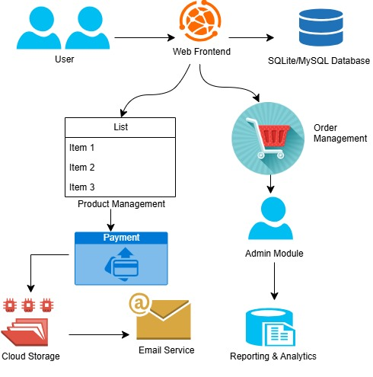

CHAPTER 3: MODULE DESCRIPICTION

3.1 User Management Module
- Stores user information such as username, email, password (hashed), and contact details in the database.
- Manages user authentication by validating credentials against stored data.
- Maintains user roles (e.g., customer, admin) with corresponding access permissions.
- Tracks user registration date and last login timestamp.
- Provides mechanisms for password reset and profile updates stored in the database.

3.2 Product Management Module
- Maintains product records including product ID, name, description, price, category, and stock quantity.
- Supports CRUD (Create, Read, Update, Delete) operations on products via database queries.
- Links product images and additional metadata stored in related tables.
- Tracks product availability and stock levels to prevent overselling.
- Allows searching and filtering products based on categories and attributes stored in the DB.

3.3 Cart and Order Module
- Stores users’ cart items with product IDs, quantities, and prices in temporary or persistent tables.
- Converts cart data into orders by creating order records with status, total amount, and timestamps.
- Links orders with user IDs and shipping details stored in the database.
- Updates product stock quantities upon successful order placement.
- Tracks order history and status changes (e.g., pending, shipped, delivered).

3.4 Payment Module
- Records payment transactions linked to order IDs with payment status and amount in the database.
- Stores payment method details (e.g., credit card type, transaction IDs) securely.
- Updates order status based on payment confirmation.
- Maintains logs for successful and failed payment attempts for auditing.
- Supports refund and cancellation entries by updating transaction records.

3.5 Admin Module
- Provides database access controls to manage users, products, and orders.
- Generates reports on sales, inventory status, and user activity using aggregated data.
- Enables administrative CRUD operations on product and user records.
- Monitors database logs and system errors to ensure smooth platform operation.
- Manages configuration settings stored in database tables for system parameters.
CHAPTER 4: CONCLUSION & FUTURE SCOPE

Conclusion
The Simple E-Commerce Platform designed using a robust Database Management System provides an efficient way to manage users, products, orders, and payments seamlessly. The modular approach ensures scalability and ease of maintenance, enabling smooth user experiences from browsing products to completing transactions. The system's core features ensure data integrity, security, and reliable order processing, making it a practical solution for online shopping needs.
Future Scope
- Integration of Advanced Payment Gateways: Adding support for more secure and diverse payment options such as digital wallets and cryptocurrencies.
- Real-Time Inventory Management: Implementing live stock updates with automated notifications for low inventory to avoid overselling.
- Personalized Recommendations: Utilizing data analytics and machine learning to suggest products based on user behavior and preferences.
- Mobile Application Development: Creating dedicated mobile apps for better accessibility and enhanced user engagement.
- Enhanced Security Features: Incorporating multi-factor authentication and advanced encryption to safeguard user data and transactions.
- Multi-language and Multi-currency Support: Expanding platform accessibility for global users with localization features.

CHAPTER 5: APPENDIX A - SOURCE CODE

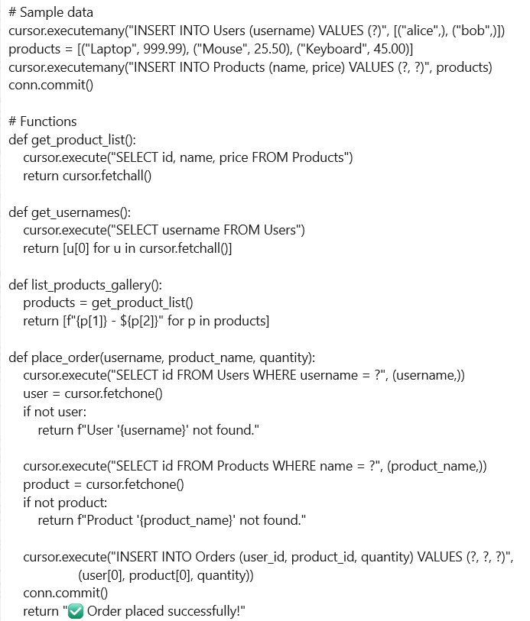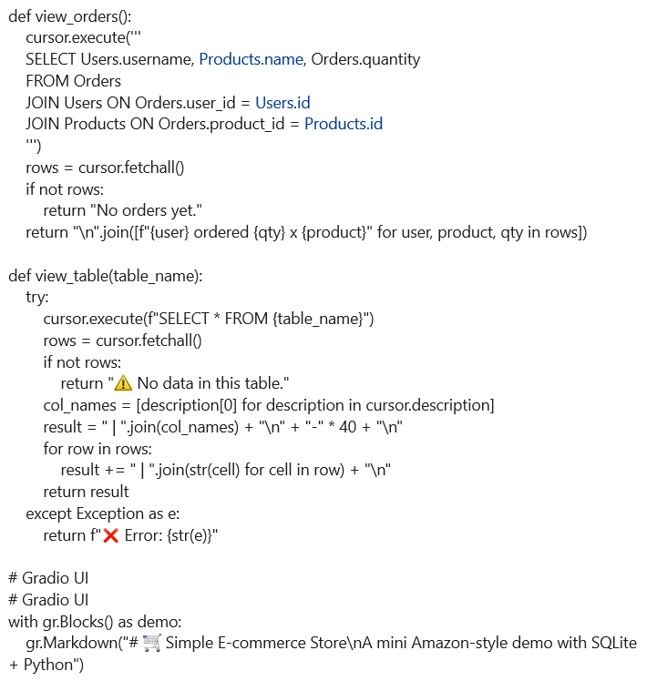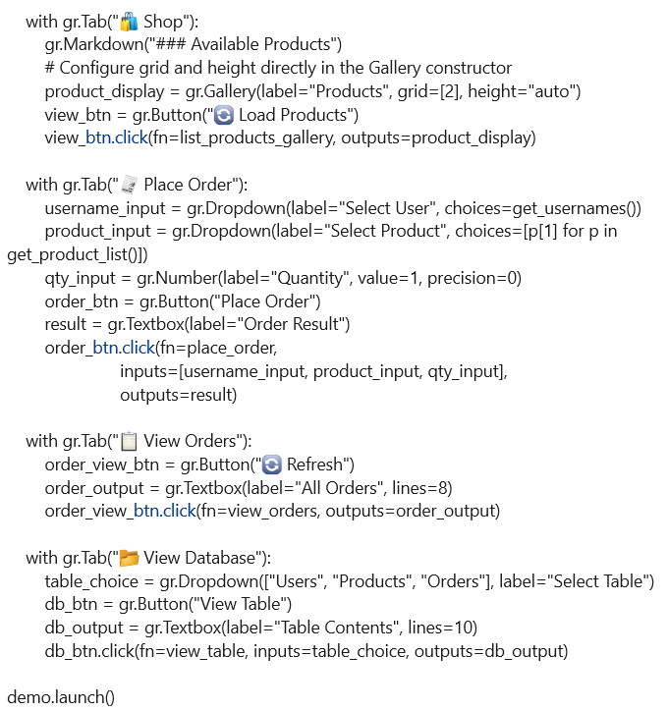

APPENDIX B - SCREENSHOTS
STEP 1:



STEP 2:
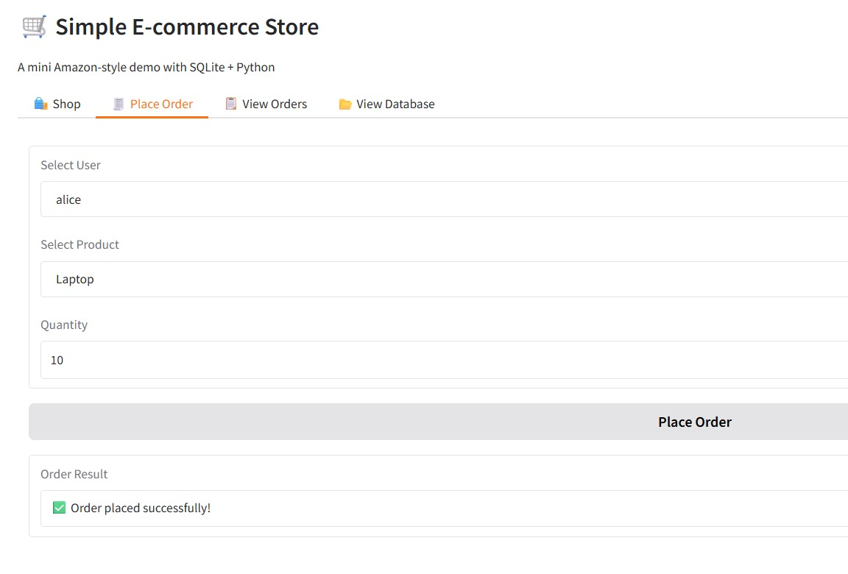

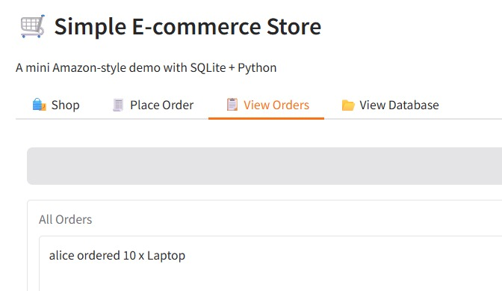
STEP 3:

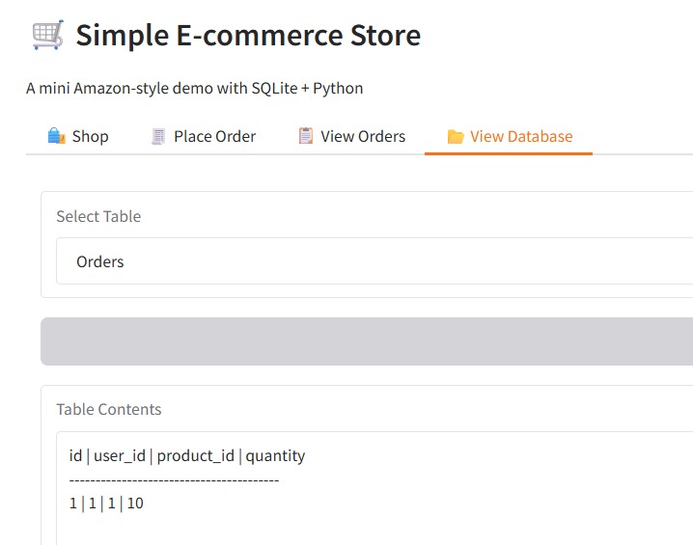
STEP 4:
REFERENCES
APA:
Author/Organization. (Year, Month Day). Title of webpage. Site name. URL
Example:
W3Schools. (n.d.). SQL Tutorial. W3Schools. https://www.w3schools.com/sql/
MLA:
“Title of Webpage.” Website Name, Publisher (if different from website name), Date of publication, URL. Accessed Day Month Year.
Example:
“SQL Tutorial.” W3Schools, https://www.w3schools.com/sql/. Accessed 17 May 2025.
IEEE:
[2] W3Schools, "SQL Tutorial," https://www.w3schools.com/sql/, accessed May 17, 2025.

